1.

*Summary:* Fix for Bug #1: Text says “More resident zones needed.” but should be “More residential zones needed.”

*Description:* Change NEED_RES

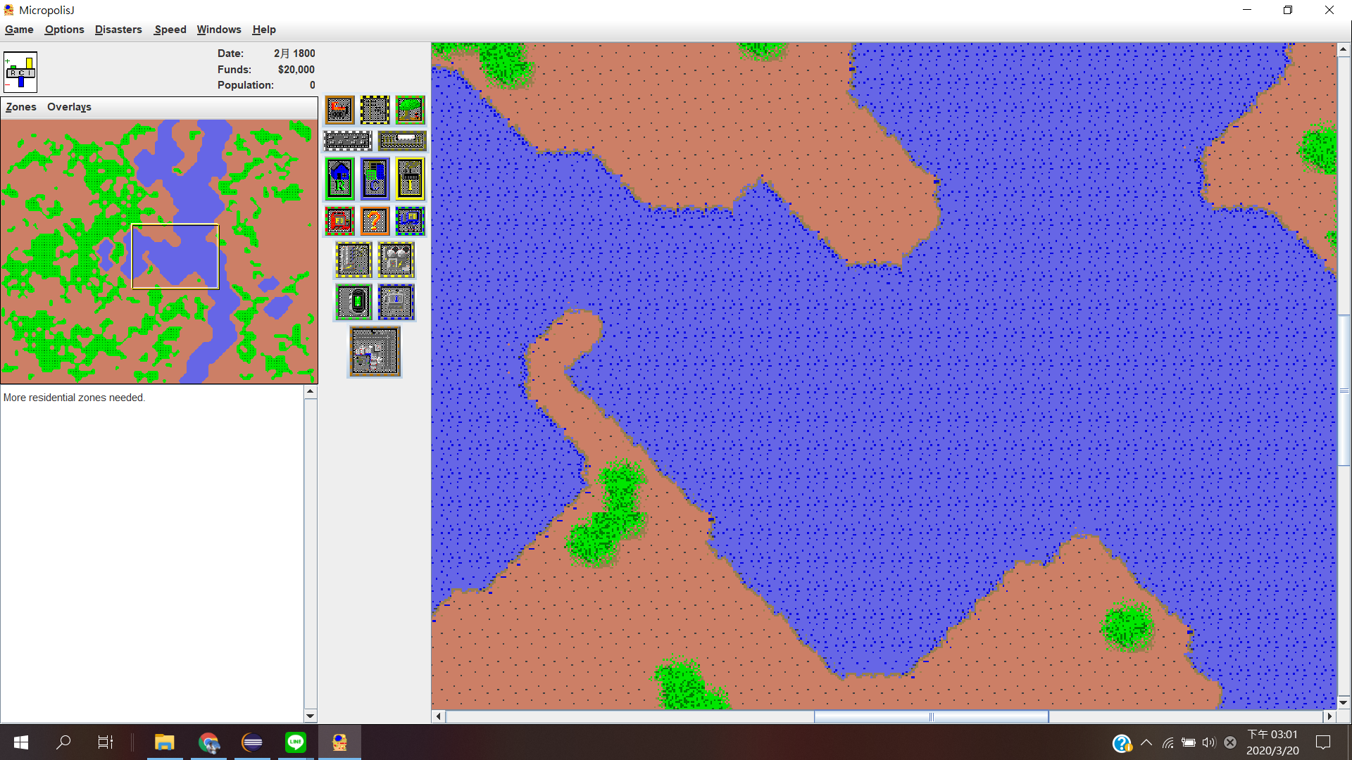

2.*Summary:* Fix for Bug #2: Game starts on January 1800 but should start on January 1900

*Description:* Change String formatGameDate

c.set(1800 + cityTime/48

1800 to 1900

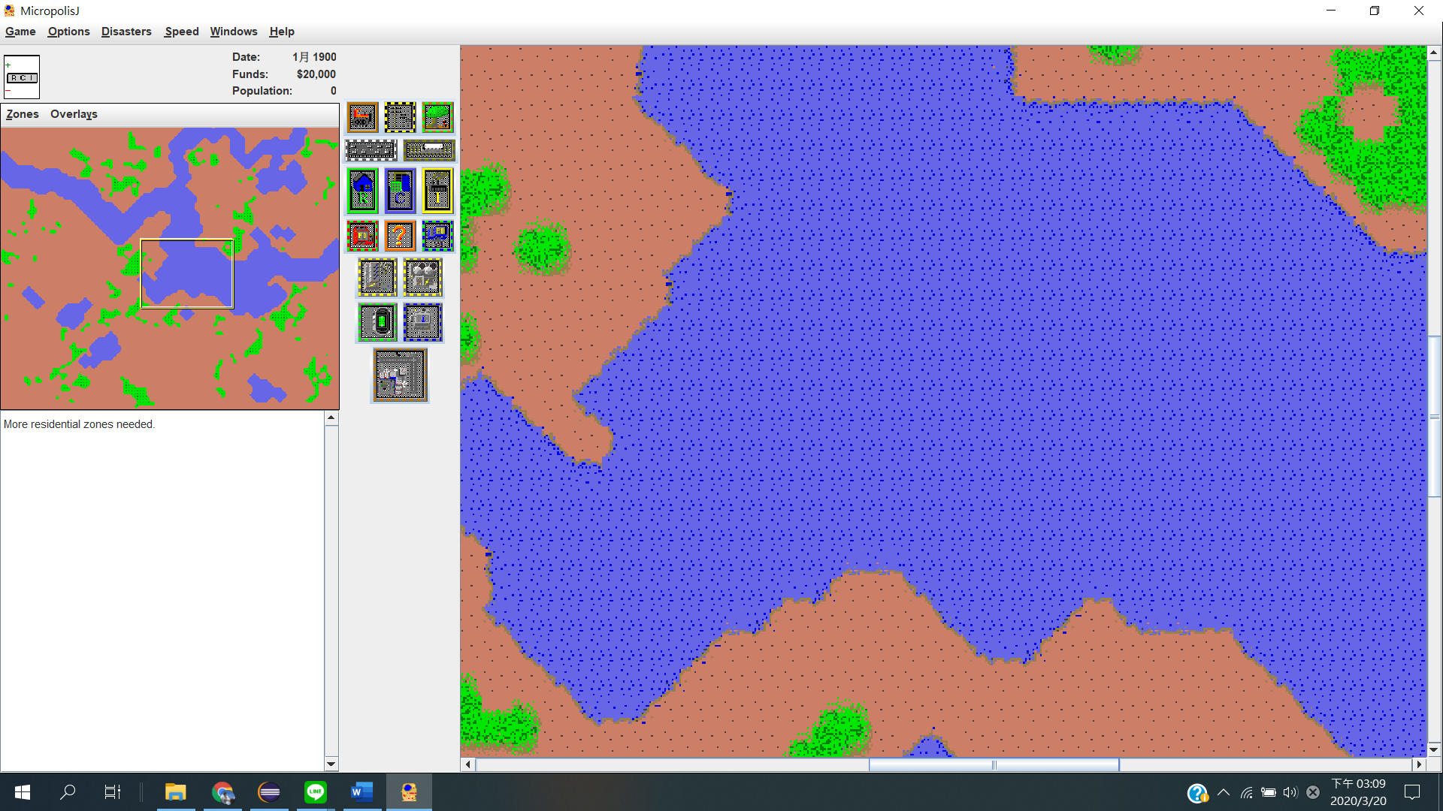

3.

*Summary:* Fix for Bug #3: Player can’t bulldoze rubble tiles. Should be able to bulldoze rubble

*Description:* Change tiles.rc

BEGIN RUBBLE (4 frames) #

44 terrain@0,704 (noburn)(description=#3)

45 terrain@0,720 (noburn)(description=#3)

46 terrain@0,736 (noburn)(description=#3)

47 terrain@0,752 (noburn)(description=#3)

change noburn into bulldozable

4. *Summary:* Fix for Bug #4: After a little bit of time the Fire Station changes into a broken version of the Police Station: The Fire Station should stay a Fire Station

*Description:*

5. *Summary:* Fix for Bug #5: Flooding should only start on tiles that are the edges of water

*Description:*

**static** **boolean** isFloodable(**int** tile)

{

//assert (tile & LOMASK) == tile;

**assert** (*isRiverEdge*(tile)) == **true**;

**return** (tile == ***DIRT*** || (*isDozeable*(tile) && *isCombustible*(tile)));

}